**Outlook 2010 - Create an Email Signature**

1. Open a new message. On the Message tab, click Signature, and then click Signatures.

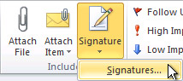

1. On the E-mail Signature tab, click New.
2. Copy the following signature, and then click OK.

**Your name**  
Your title | Your desk

[](http://www.edenbrown.com/?utm_source=talisman_logo&utm_medium=email&utm_campaign=signature)

Specialist recruiters across the Built Environment

#Your address goes here#

Description: http://data.i-resource.co.uk/ir/mar/Eden%20Brown/phone.jpg **000 0000 0000**cid:image003.jpg@01D0B579.2A334DE0 **000 0000 0000**

**http://data.i-resource.co.uk/ir/mar/Eden%20Brown/fax.jpg 000 0000 0000  
http://data.i-resource.co.uk/ir/mar/Eden%20Brown/mail.jpg your.email@edenbrown.com**  
**http://data.i-resource.co.uk/ir/mar/Eden%20Brown/web.jpg**[**www.edenbrown.com**](http://www.edenbrown.com/?utm_source=talisman&utm_medium=email&utm_campaign=signature) **http://data.i-resource.co.uk/ir/mar/Eden%20Brown/work.jpg**[**see our latest jobs**](http://www.edenbrown.com/job-search/search/?utm_source=talisman_jobs&utm_medium=email&utm_campaign=signature)

http://data.i-resource.co.uk/ir/mar/Eden%20Brown/follow-us.jpg[http://data.i-resource.co.uk/ir/mar/Eden%20Brown/Facebook.jpg](https://www.facebook.com/EdenBrownRecruit)[http://data.i-resource.co.uk/ir/mar/Eden%20Brown/Twitter.jpg](https://twitter.com/eden_brown) [http://data.i-resource.co.uk/ir/mar/Eden%20Brown/linkedin-icon.jpg](https://uk.linkedin.com/company/eden-brown)

[](http://www.nspcc.org.uk/)

1. To finish creating the signature, click OK.
2. Share this document with everyone in your team so they also update their signature as well.

**How to add hyperlinks to Outlook 2010 signatures**

1. Open a new message. On the Message tab, in the Include group, click Signature, and then click Signatures.



1. On the signatures menu, select your signature. Go to the “Connect with me” icon and select it – once selected, go the icon “hyperlink” on the top right hand side and click to open the menu.

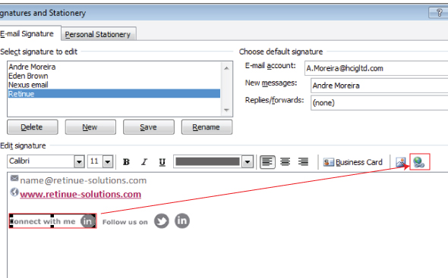

1. On the insert hyperlink menu, add your “LinkedIn profile” address and then press OK to save.

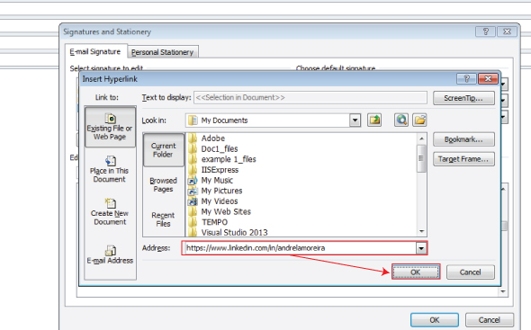

1. On the signatures menu, press OK again to save and close. Once it’s done, your signature is completed.