your
global

recruitment partner

for us the world has no borders

specialists who recruit and advise in the fields of infrastructure & natural resources

www.ewirecruitment.com
ewi recruitment 222 bishopsgate
city of london, ec2m 4qd t: 0044 (0) 20 7877 8350
f: 0845 434 9573
info@ewirecruitment.com

ewi recruitment is an international consultancy formed of specialist technical consultants who recruit and advise in the fields of infrastructure and natural resources.

our promise
our commitment our goal

each division and consultant within ewi recruitment
is focussed exclusively on their specialist remit. we guarantee a network
which has been intensively developed and nurtured, providing access to leading industry professionals.
we strive to lead the way in a global market through consistently raising the standard of candidates delivered and providing
a knowledgeable and specialist approach to the recruitment process.
it’s simple. to become the world’s leading specialist consulting engineering recruitment company and to supply our expertise to the largest and most iconic projects around the world.

rail

ewi rail team offer technical support to ensure that you get the market leading expertise you need to guarantee success.

ewi is an international consultancy formed of specialist technical consultants who recruit and advise in the fields of infrastructure and natural resources. each division and consultant within ewi is focussed exclusively on their specialist remit. similarly our network has been developed and nurtured, providing access to over 25,000 industry specific professionals across each vertical market. we poss unrivalled market and international project knowledge to support our clients sustainable success.

our specialist rail team are devoted to the provision of technical expertise to leaders within the market. within this sector we work in the fields of construction, consultancy, and engineering. in short the railway team at ewi are able to help our clients deliver railway projects from concept to turnkey and onto the operational and maintenance. our networks span feasibility, design, site supervision, commissioning & testing and handover to service all aspects of the project lifecycle.

successful delivery on some of the worlds leading rail projects including but not limited to; the Qatar Doha Metro, Saudi Arabia Haramain High Speed Rail, China Beijing High Speed, Malaysia Klang Valley Metro, Denmark Copenhagen Metro, India Kolkata Metro as well as many more of the worlds leading rail projects. the ewi rail team have experience working on metro projects, light rail, underground and freight rail projects.

all endorsed candidates have extensive references taken from previous projects and employers to ensure the reliability, professionalism, and value of any prospective hire. ewi custom internal database allows us to search tens of thousands of experts for specific criteria including:

- civil engineers
- operational & maintenance
- overhead line/catenary
- power & electrification
- project managers/directors
- pway/track engineers
- railway systems
- rolling stock
- safety assessors
- signalling engineers
- system assurance/RAMS
- telecoms engineers

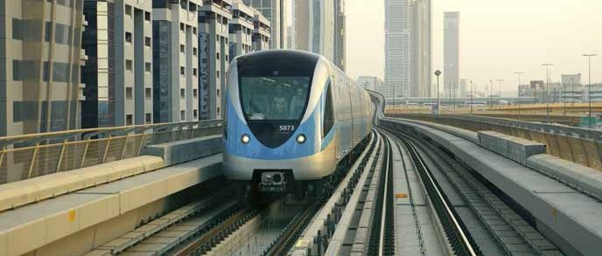

solutions are provided to cater for our clients unique requirements and to support all aspects of a global marketplace. these include:

- executive search
- international human resource advisory service
- strategic hire
- total project solution

for more information, please contact our rail team via the details below: email: rail@ewirecruitment.com
tel: +44 (0) 207 877 8350

tunnels

ewi tunnels team offer technical support to ensure that you get the market leading expertise you need to guarantee success.

ewi is an international consultancy formed of specialist technical consultants who recruit and advise in the fields of infrastructure and natural resources. each division and consultant within ewi is focussed exclusively on their specialist remit. similarly our network has been developed and nurtured, providing access to over 25,000 industry specific professionals across each vertical market. we posses unrivalled market and international project knowledge to support our clients sustainable success.

our specialist tunnelling and underground structures division are leaders within the industry. they are a central figure in the tight knit and exclusive community of professionals from tunnelling, geotechnical and foundations backgrounds. our team is depended upon by market leading businesses to locate, support and mobilise key expertise to some of the worlds largest projects. we support transportation, infrastructure and power markets whilst providing a global reach for our clients. our division understands local conditions, ground types, rock formations and the techniques required to ensure successful completion. we work with our clients to establish the profile required and use our network of specialists to source expertise.

successful delivery on some of the worlds leading transport and power projects has demonstrated our abilities in large scale, senior level recruitment. we have partnered winning tenders, provided design experts to prepare major structural plans and construction management to see the project through to completion on time and within budget. the world is going underground, we are a leader in supplying the expertise and insight needed to enable the tunnelling industry to continue to grow.

all endorsed candidates have extensive references taken from previous projects and employers to ensure the reliability, professionalism, and value of any prospective hire. ewi custom internal database allows us to search tens of thousands of experts for specific criteria including:

- construction management
- design experts
- geologists
- geotechnical engineers
- HVAC/MEP
- manufacturing
- QA/QC and inspection
- resident engineers
- tunnelling engineers

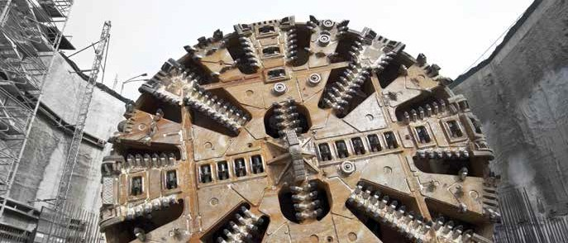

solutions are provided to cater for our clients unique requirements and to support all aspects of a global marketplace. these include:

- executive search
- international human resource advisory service
- strategic hire
- total project solution

for more information, please contact our tunnels team via the details below: email: tunnel@ewirecruitment.com

power

ewi power team offer technical support to ensure that you get the market leading expertise you need to guarantee success.

ewi is an international consultancy formed of specialist technical consultants who recruit and advise in the fields of infrastructure and natural resources. each division and consultant within ewi is focussed exclusively on their specialist remit. similarly our network has been developed and nurtured, providing access to over 25,000 industry specific professionals across each vertical market. we posses unrivalled market and international project knowledge to support our clients sustainable success.

our specialist power consultants lead the International market and through many years development have a vast knowledge, experience and networks across the power industry with a focus on two main areas. the power generation fields includes projects based around fossil fuel, wind, solar, waste-to-energy, nuclear, geothermal and biomass plants for pure power generation projects and also desalination, manufacturing & Industrial developments around the world. transmission and distribution is the second part of the power market within ewi and thus we have focused a large amount of resources in developing this sector focusing on urban and rural donor funded projects, as well as substation and transmission networks across the developed and developing world.

having spent many years within the Industry we have worked with a wide range of clients including consultant, contractor and manufactures and provided key experts for a number of major projects around the world. from our network of 25,000 engineers we have been able to source candidates who meet specific project, regional, language and qualification requirements laid out by our clients. our versatility allows us to react quickly to meet difficult requirements ensuring that projects do not suffer delays or complications.

all endorsed candidates have extensive references taken from previous projects and employers to ensure the reliability, professionalism, and value of any prospective hire. ewi custom internal database allows us to search tens of thousands of experts for specific criteria including:

- commissioning engineers/managers
- construction managers/supervisors
- E&I engineers
- electrical, mechanical, civil & structural engineers
- project managers/directors
- resident engineers/owners engineers
- substation engineers

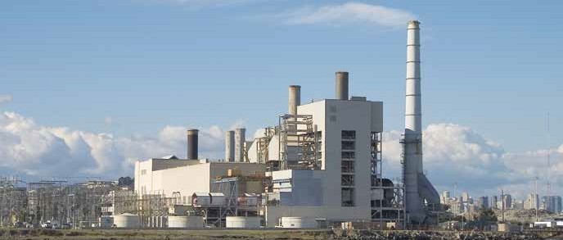

solutions are provided to cater for our clients unique requirements and to support all aspects of a global marketplace. these include:

- total project solution
- executive search
- international human resource advisory service
- strategic hire

for more information, please contact our power team via the details below: email: power@ewirecruitment.com

hydropower

ewi hydropower team offer technical support to ensure that you get the market leading expertise you need to guarantee success.

ewi is an international consultancy formed of specialist technical consultants who recruit and advise in the fields of infrastructure and natural resources. each division and consultant within ewi is focussed exclusively on their specialist remit. similarly our network has been developed and nurtured, providing access to over 25,000 industry specific professionals across each vertical market. we posses unrivalled market and international project knowledge to support our clients sustainable success.

our specialist hydropower consultants are focused on the feasibility design through to the construction supervision of large dam and hydropower schemes. our years of recruiting expertise and geographical coverage have allowed us to provide key expert staff to many of the worlds leading projects across Africa, South America, South America and Europe among others. we offer our clients vast experience in identifying engineers & experts for both tenders and live projects, funded by various government/donor and privately funded assignments including World Bank, ADB, KfW, EBRD.

ewi are constantly speaking with hydropower experts and have the in-depth knowledge of who’s available in the Market. having a truly International focus, we recruit for all language sets with a focus on English, German, Russian, Italian, French, Mandarin, Spanish, Arabic
& Portuguese speakers. working closely with both our tunnelling/geotechnical and power team, we have a thorough understanding of hydropower projects from conception through to completion.

all endorsed candidates have extensive references taken from previous projects and employers to ensure the reliability, professionalism, and value of any prospective hire. ewi custom internal database allows us to search tens of thousands of experts for specific criteria including:

- construction managers
- chief resident engineers/team leaders
- hydro-mechanical & electrical engineers
- project managers/directors
- owners engineers
- commissioning & installation

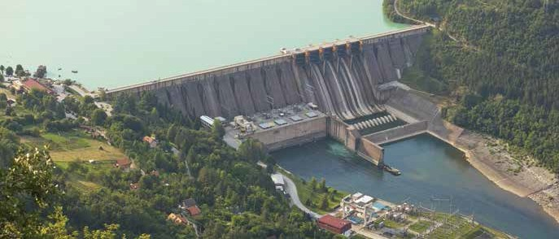

solutions are provided to cater for our clients unique requirements and to support all aspects of a global marketplace. these include:

- executive search
- international human resource advisory service
- strategic hire
- total project solution

for more information, please contact our hydropower team via the details below: email: hydropower@ewirecruitment.com
tel: +44 (0) 207 877 8350

highways

ewi highways team offer technical support to ensure that you get the markets leading expertise you need to guarantee success.

ewi is an international consultancy formed of specialist technical consultants who recruit and advise in the fields of infrastructure and natural resources. each division and consultant within ewi is focussed exclusively on their specialist remit. similarly our network has been developed and nurtured, providing access to over 25,000 industry specific professionals across each vertical market. we posses unrivalled market and international project knowledge to support our clients sustainable success.

our specialist highways team are focused on major highway projects around the globe. in addition to work on highway schemes the ewi highways team are also involved with associated structures including but limited to various bridge projects. the highways team cover all stages including feasibility, design, construction, maintenance and technical assistance.

the highway team at ewi recruitment have recruited for many of the major road & bridge projects around the world. the team offer key experts and have helped our clients win deliver some of the world most challenging schemes around the globe. we offer our clients our vast experience in identifying experts for tenders and approvals that will score maximum points on both financial and technical elements. recruiting for many language sets including English, French, Spanish, Portuguese and German.

all endorsed candidates have extensive references taken from previous projects and employers to ensure the reliability, professionalism, and value of any prospective hire. ewi custom internal database allows us to search tens of thousands of experts for specific criteria including:

- chief resident engineers/team leaders
- QA/QC engineers
- resident engineers/highways engineers
- pavement engineers
- material engineers
- highway designers

solutions are provided to cater for our clients unique requirements and to support all aspects of a global marketplace. these include:

- total project solution
- strategic hire
- executive search
- international human resource advisory service

for more information, please contact our highways team via the details below: email: highways@ewirecruitment.com
tel: +44 (0) 207 877 8350

commercial & contracts

ewi commercial & contracts team offer technical support to ensure that you get the market leading expertise you need to guarantee success.

ewi is an international consultancy formed of specialist technical consultants who recruit and advise in the fields of infrastructure and natural resources. each division and consultant within ewi is focussed exclusively on their specialist remit. similarly our network has been developed and nurtured, providing access to over 25,000 industry specific professionals across each vertical market. we posses unrivalled market and international project knowledge to support our clients sustainable success.

our specialist commercial & contracts consultants are industry leaders in the recruitment of commercial, contracts, project controls and planning professionals for private and donor funded projects throughout the world. we supply entry to director level staff across a variety of projects including, transport infrastructure, commercial build, education, oil and gas, power, mining, marine and industrial.

the ewi commercial & contracts team have worked with some of the world’s leading construction and engineering practices, assisting in sourcing entire teams for projects to finding and recruiting key functional hires. our team proactively search and attract the best talent within the market, delivering a high quality and efficient service, whether it is for a single requirement to full project staffing.

all endorsed candidates have extensive references taken from previous projects and employers to ensure the reliability, professionalism, and value of any prospective hire. ewi custom internal database allows us to search tens of thousands of experts for specific criteria including:

- claims specialists
- commercial managers & contracts managers
- cost managers
- delay analysts
- expert witness
- planning managers & scheduling engineers
- project controls managers
- quantity surveyors

solutions are provided to cater for our clients unique requirements and to support all aspects of a global marketplace. these include:

- total project solution
- strategic hire
- executive search
- international human resource advisory service

for more information, please contact our commercial & contracts team via the details below: email: commercial@ewirecruitment.com
tel: +44 (0) 207 877 8350

water

ewi water and wastewater team offer technical support to ensure that you get the market leading expertise you need to guarantee success.

ewi is an international consultancy formed of specialist technical consultants who recruit and advise in the fields of infrastructure and natural resources. each division and consultant within ewi is focussed exclusively on their specialist remit. similarly our network has been developed and nurtured, providing access to over 25,000 industry specific professionals across each vertical market. we posses unrivalled market and international project knowledge to support our clients sustainable success.

our specialist water and wastewater consultants lead the International market and posses in depth market knowledge, technical experience with exceptional strong candidate networks spread across the globe. the team specialise in the provision of key experts and senior staff working on donor, government and privately funded projects across Europe, Asia, Africa and the Middle East.

the ewi water team have worked with some of the world’s leading engineering practices, assisting in sourcing entire teams for projects to finding and recruiting key functional hires. the capabilities and experiences that our experts have cover master planning, feasibility, detailed design, technical assistance, construction supervision, installation, commissioning, O&M, environmental, procurement, contracts, water sector reform, institutional strengthening and capacity building.

all endorsed candidates have extensive references taken from previous projects and employers to ensure the reliability, professionalism, and value of any prospective hire. ewi custom internal database allows us to search tens of thousands of experts for specific criteria including:

- water supply
- sewerage
- WWTP
- drainage
- irrigation
- wastewater
- solid waste
- industrial
- desalination
- NRW

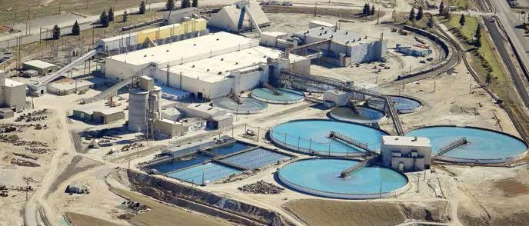

solutions are provided to cater for our clients unique requirements and to support all aspects of a global marketplace. these include:

- total project solution
- strategic hire
- executive search
- international human resource advisory service

for more information, please contact our water team via the details below: email: water@ewirecruitment.com
tel: +44 (0) 207 877 8350

recruitment solutions

solutions are provided to cater for our clients unique requirements and to support all aspects of a global marketplace.

the solutions are catered to each area of a business and include:

total project solution strategic hire

- solutions for critical project roles to complete and improve the delivery of a key project.
- full cycle project recruitment to source and supply a workforce on a large scale. This will include handling of all search, selection and international mobilisation.
- our project solutions cover all stages of the project lifecycle, from;
- conception-feasibility-bid stage-design-construction- operation
- senior appointments and key roles within a business that require both an in depth understanding of the technical criteria for a role, and of the ethos and expectations of the employer.

executive search international hr advisory

- we offer a bespoke, high-end search for all integral hires within a global business.
- this includes the exclusive provision of senior consultants time and efforts to establish, analyse, service and supply the unique criteria of the hire.
- we offer retained solutions to attract and head-hunt globally renowned talent from director level and above to add true value to a business.
- for our key clients we can provide a complete human resource advisory to support the business.
- this is a structured solution to fully encompass all areas of project delivery, international mobilisation, resource management and market development.

ewi recruitment | info@ewirecruitment.com | +44 (0) 20 7877 8350

ewi is part of the HBHC Group of companies and has access to resources of over 20 other specialist recruitment businesses covering; admin & support, facilities, maintenance and oil & gas which can be called upon if required for technical assistance.

about HCIG

Human Capital Investment Group (HCIG) is a london-based recruitment business with an enviable reputation in the staffing and resourcing sector.

covering numerous sectors from building services, charities and not- for-profit, to engineering, housing and social care from a network of regional offices, we inspire the very best recruitment professionals to develop their careers and their businesses – fast.

with an investment model that is proven to build value, we seek out the best people and develop their skills, providing the infrastructure and expertise needed to boost sustainable and organic building growth.

by establishing trusting relationships with our chosen customers and matching their needs with brilliant services, we have created an
environment which balances direction and guidance with the desire for freedom, creativity and expression.

when a business is backed or acquired by HCIG, it grows, fast. working in partnership with us will give you all the opportunities of running your own business, combined with the support that comes from being part of one of the UK’s leading recruitment companies.

ewi recruitment | info@ewirecruitment.com | +44 (0) 20 7877 8350

ewi recruitment

222 bishopsgate, london ec2m 4qd

t: 0044 (0) 207 877 8350 f: 0044 (0) 845 434 9573
www.ewirecruitment.com info@ewirecruitment.com

